Project: Autonomous Customer Support Agent (Enterprise-Grade)

We’ll do this properly from zero to finished project, step by step.
I’ll guide you like a mentor through the full build.
🚀 Phase Plan (Start → Finish)
We will build in this order:
- Environment Setup
- Project Folder Structure
- Run Local LLM with Ollama
- Build FastAPI backend
- Build Planner Agent
- Build RAG knowledge search
- Build Tool Agent
- Add Memory (SQLite)
- Add UI with Streamlit
- Testing
- GitHub polish
- Resume + interview prep
Step 1 :
* cd agentic_support_system
* python -m venv venv
* venv\Scripts\activate
*step 2: pip install fastapi uvicorn streamlit requests faiss-cpu sentence-transformers pydantic
*step 3: Step 3: Create Clean Project Structure
Inside agentic_support_system, run:
mkdir app,data,ui
mkdir app\agents,app\core,app\memory,app\rag,app\tools
If PowerShell errors, run separately:
mkdir app
mkdir data
mkdir ui
mkdir app\agents
mkdir app\core
mkdir app\memory
mkdir app\rag
mkdir app\tools

✅ Step 4: Create Initial Files
Run:
ni app\main.py
ni app\core\llm.py
ni app\agents\planner.py
ni data\knowledge.json
ni ui\app.py
(ni = New-Item in PowerShell)

✅ Step 5: Your Final Structure Should Look Like
agentic_support_system/
│── venv/
│── app/
│ ├── main.py
│ ├── agents/
│ ├── core/
│ ├── memory/
│ ├── rag/
│ └── tools/
│── data/
│ └── knowledge.json
│── ui/
│ └── app.py

🎯 After That (Important)
Once done, send me:
structure done
Then I’ll give you the next real coding step:
🔥 Step 2 Coding
Connect Ollama with Python + create first working FastAPI API.
That’s when your project officially starts functioning.

** virtual environment activation

‘’’ cd agentic_support_system
.\venv\Scripts\Activate.ps1 ‘’’
- ollama pull phi3
- ollama run phi3
- A. python app\core\llm.py == Greetings! How can I assist you today?

Next Phase = Build Full Agentic Support System
Now we create:
Files to build next:
app/
├── agents/planner.py
├── memory/session_memory.py
├── rag/search.py
├── tools/ticket_tool.py
├── main.py
data/knowledge.json
ui/app.py
** knowledge.json data has added
** STEP 1 — app/agents/planner.py
** session_memory.py –
** search.py
** ticket_tool.py
** main.py
means these modules are functioning together:
✅ main.py orchestrating flow
✅ planner.py classifying issue
✅ session_memory.py storing context
✅ search.py retrieving data / fallback
✅ ticket_tool.py generating ticket
✅ llm.py using Ollama model
✅ Terminal execution successful

python -m app.main (priority file to run)

** python -m app.database.db
*** streamlit run ui/streamlit_ui.py
** streamlit run ui/streamlit_ui.py

***>updated to pro level project and created the folder name : support_ai_v2

- Created the sub files as well
- Created backend API files :
after saving all of backend files,

--- uvicorn main:app --reload

== uvicorn main:app --reload
== http://127.0.0.1:8000/docs

swagger docs is running :

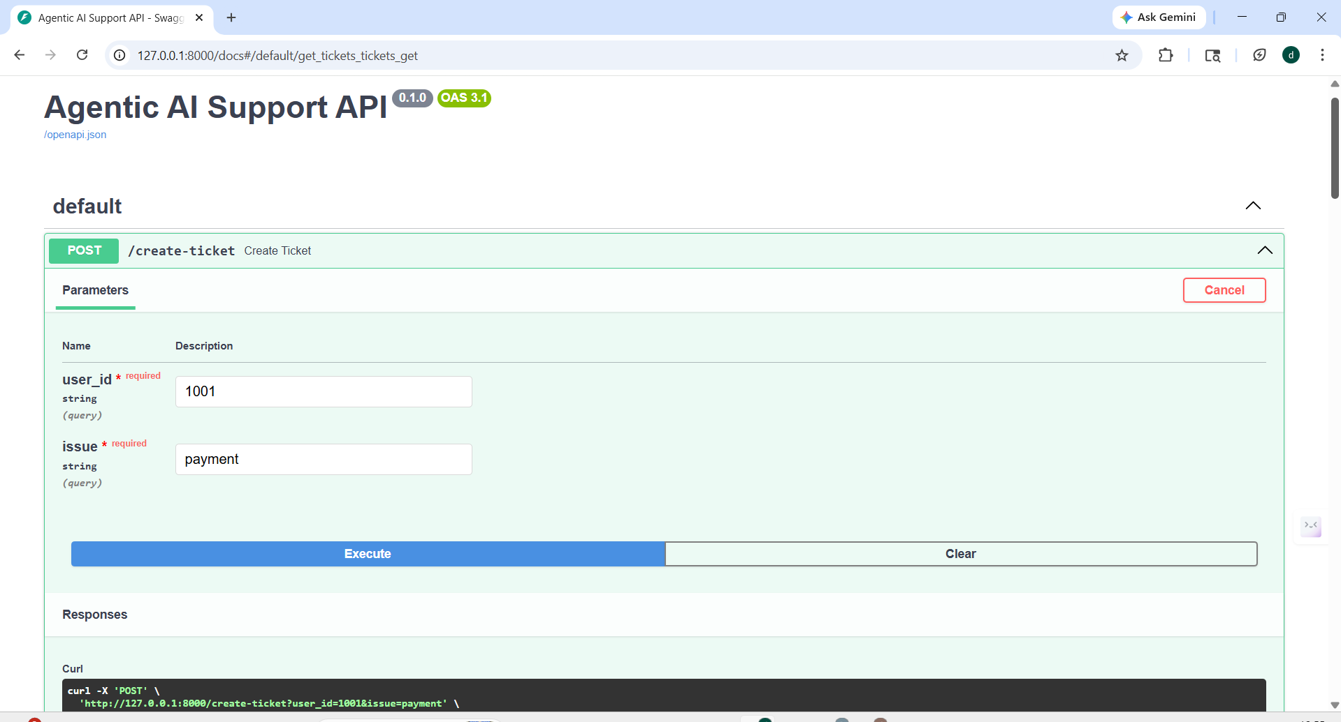
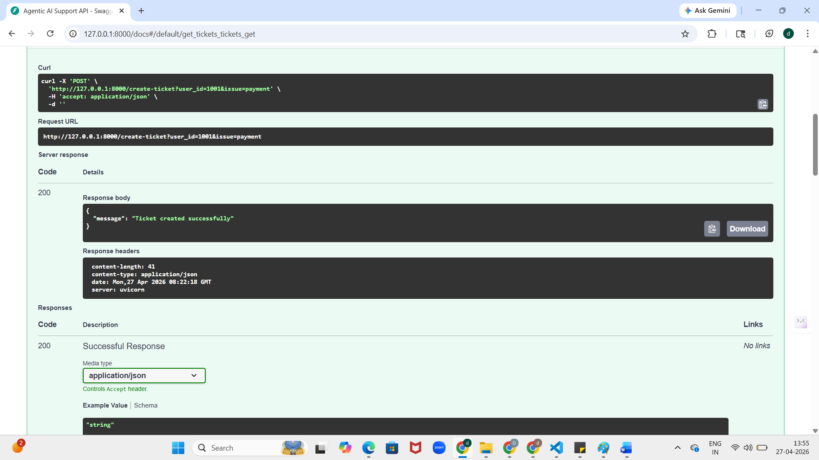

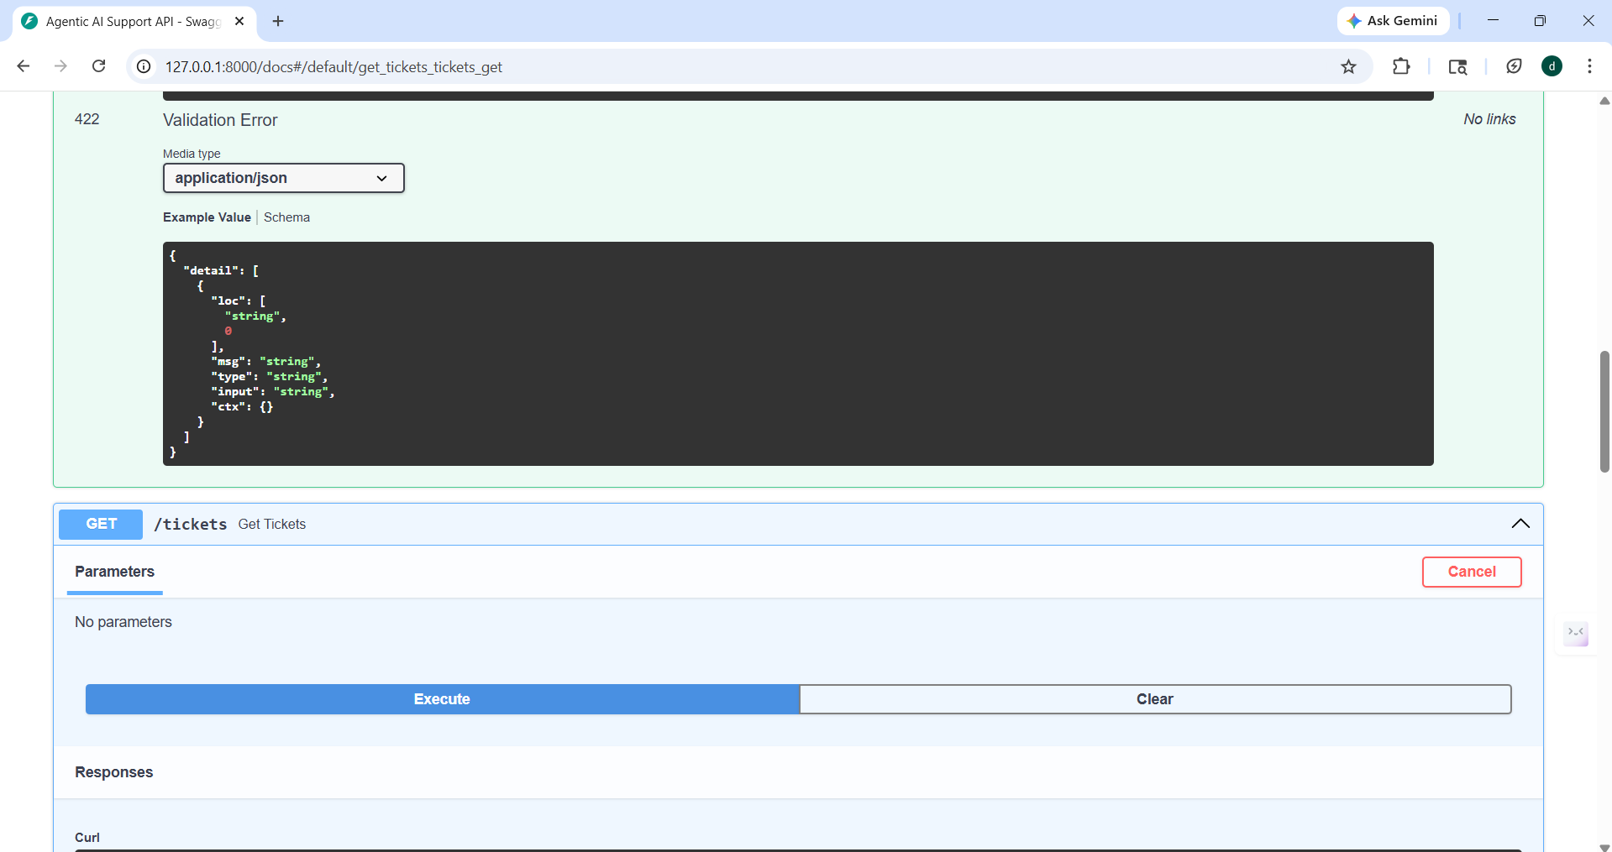

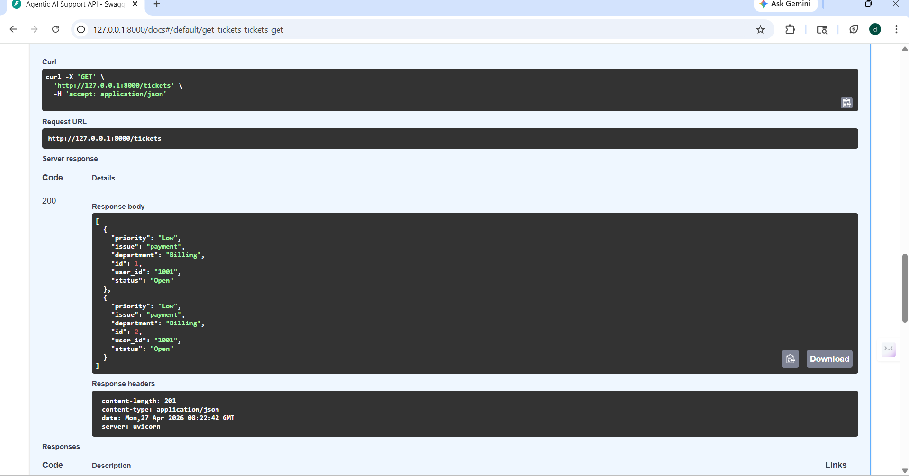

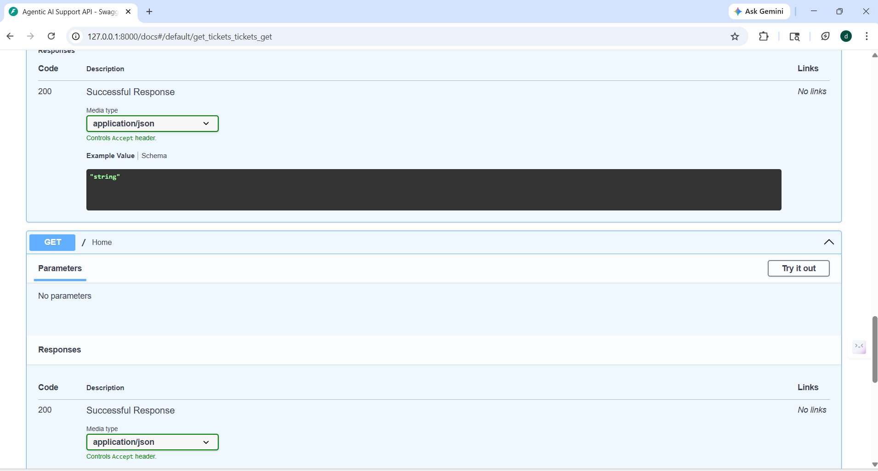

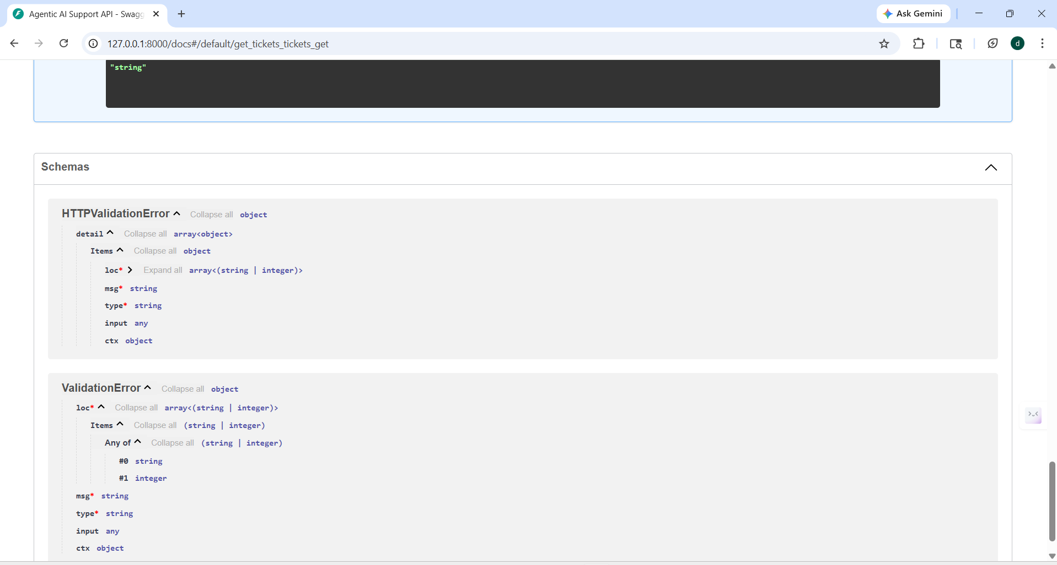

Now your project becomes Agentic AI System
Right now it is only CRUD API.

- cd support_ai_v2\backend
- cd support_ai_v2\backend
- uvicorn main:app --reload
- http://127.0.0.1:8000/docs ------- connection

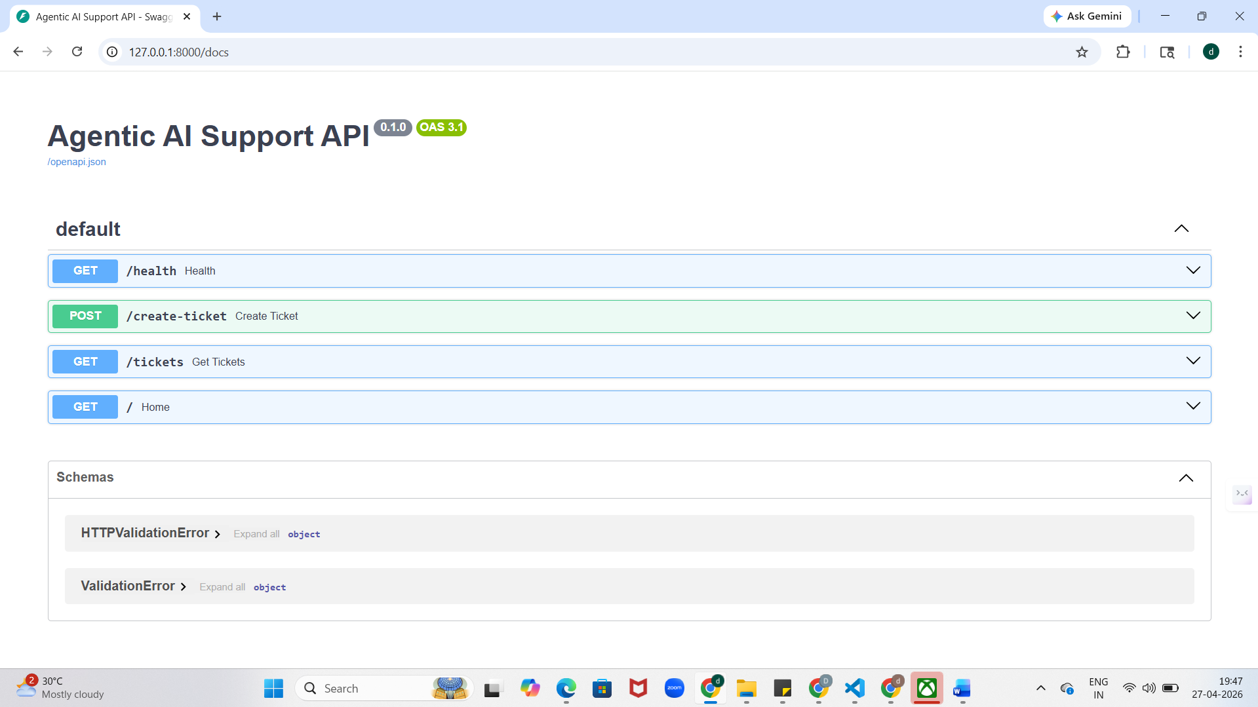

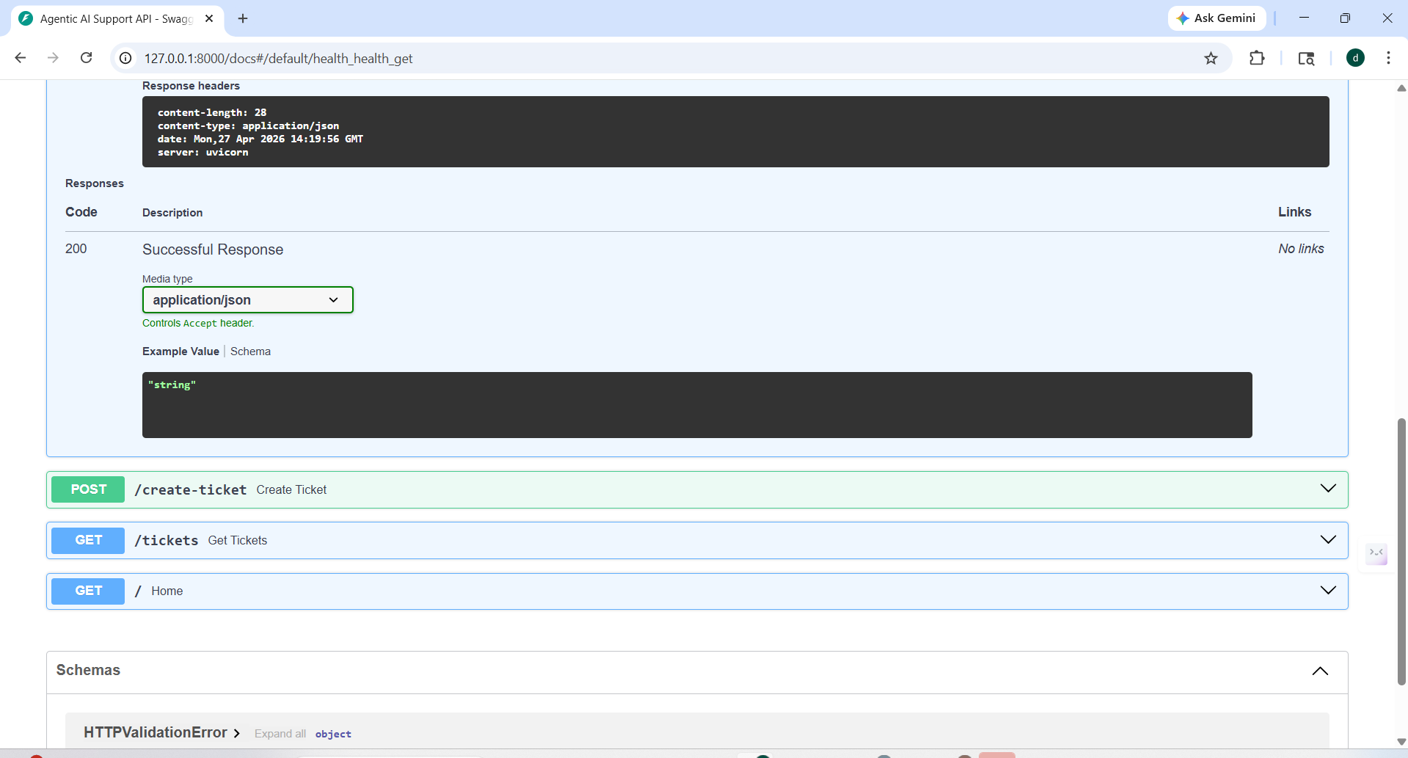
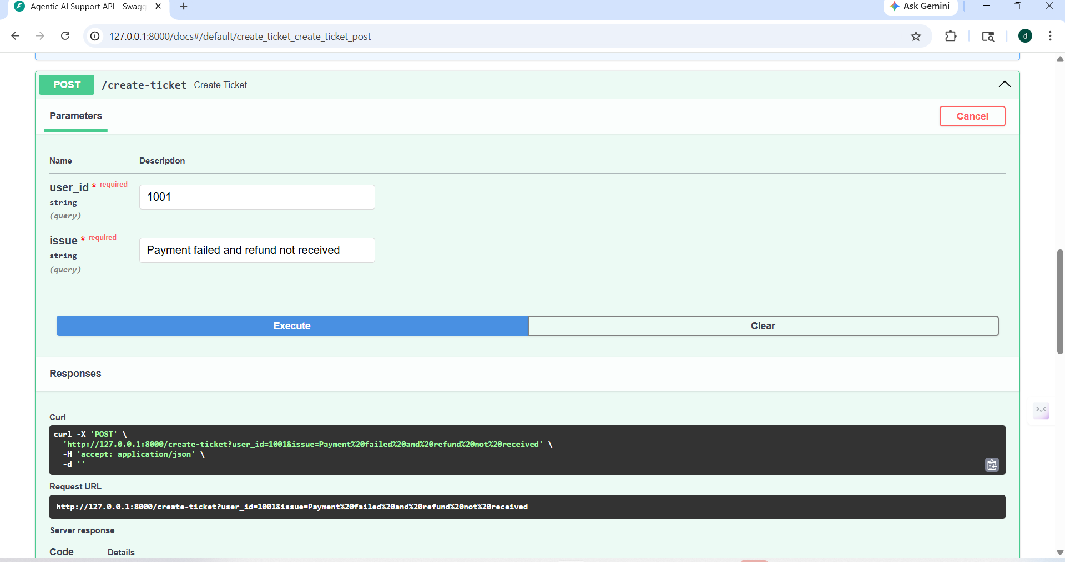

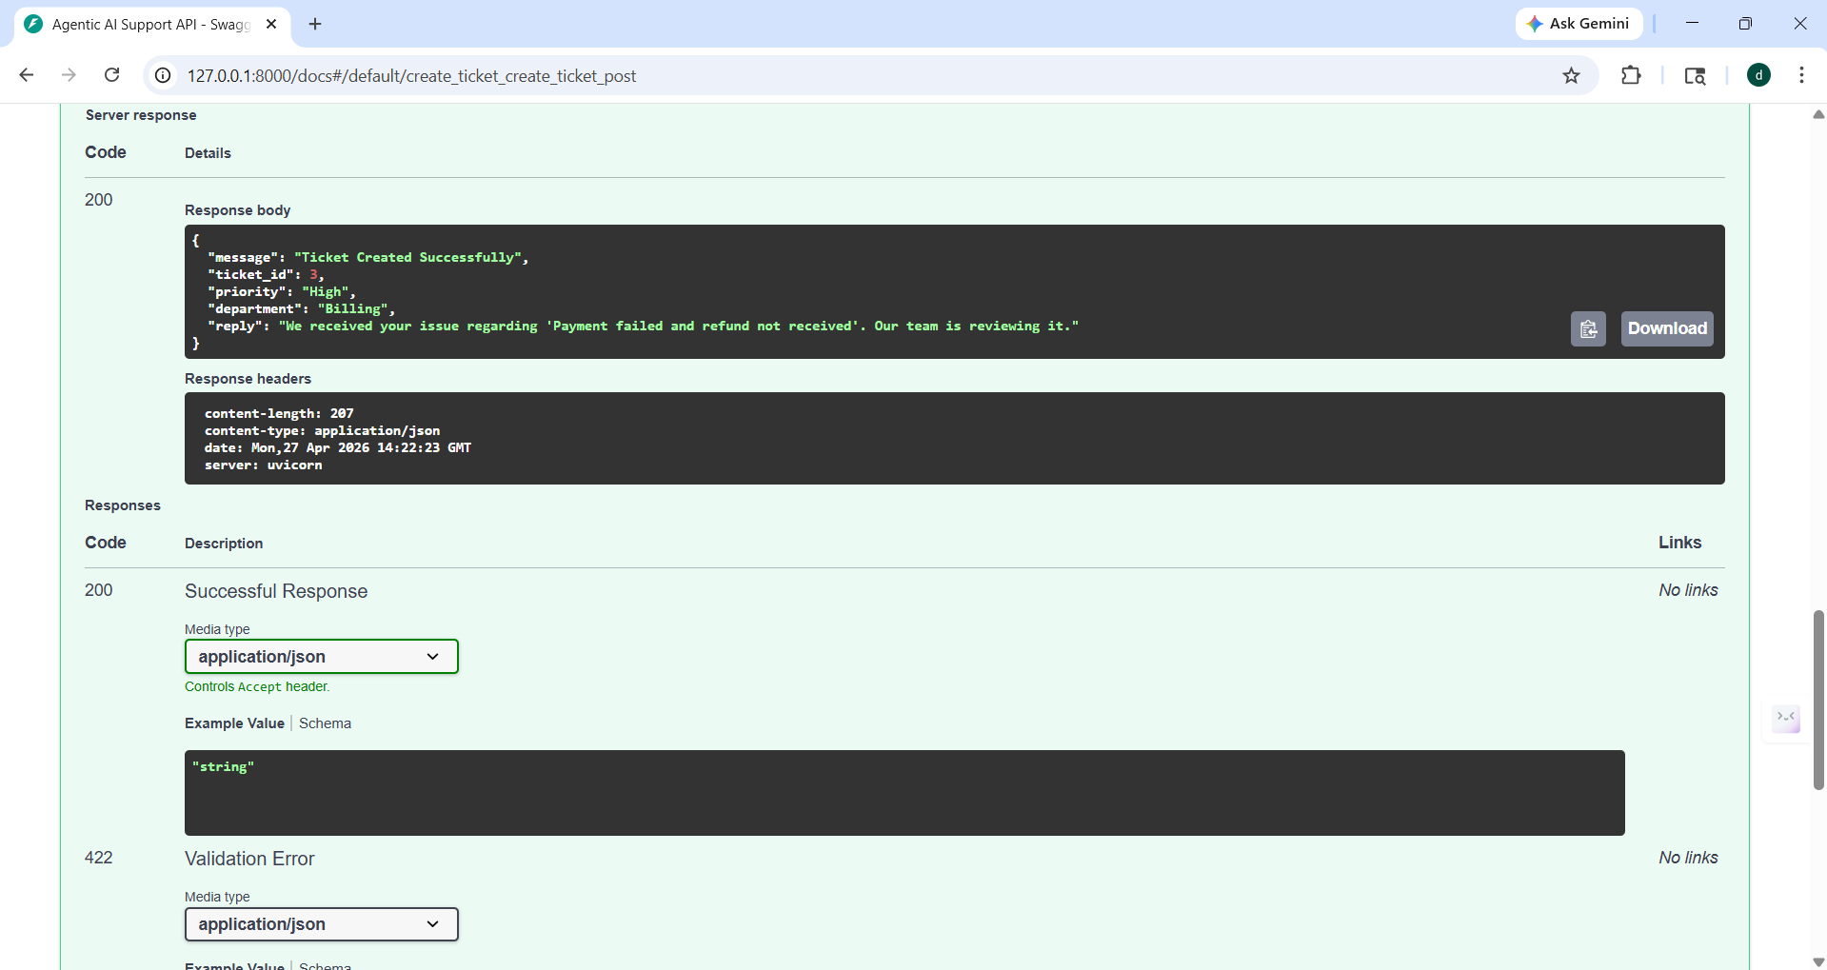

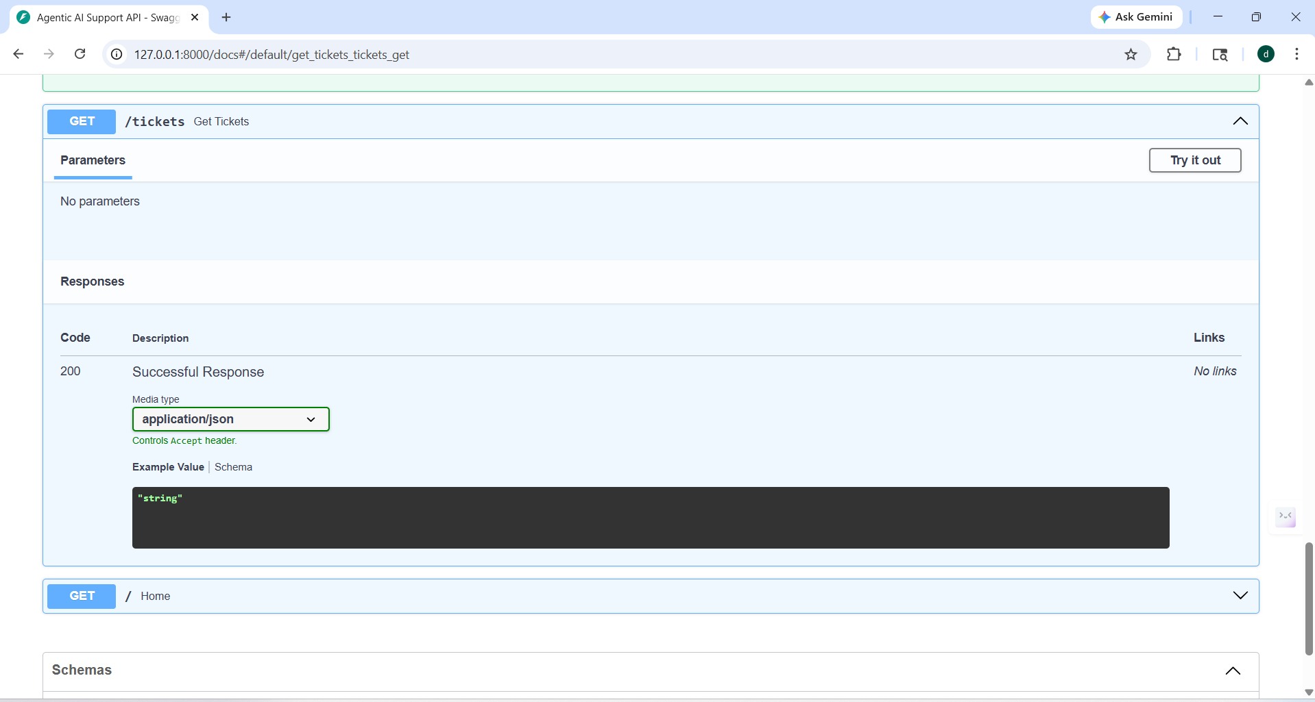
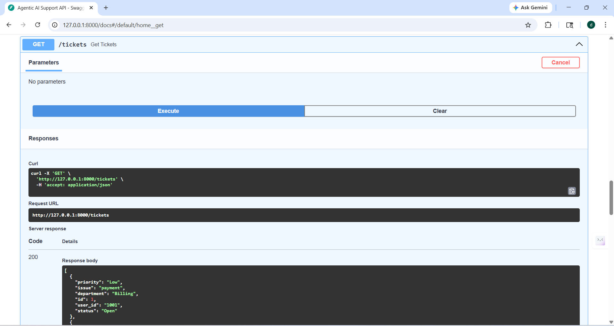
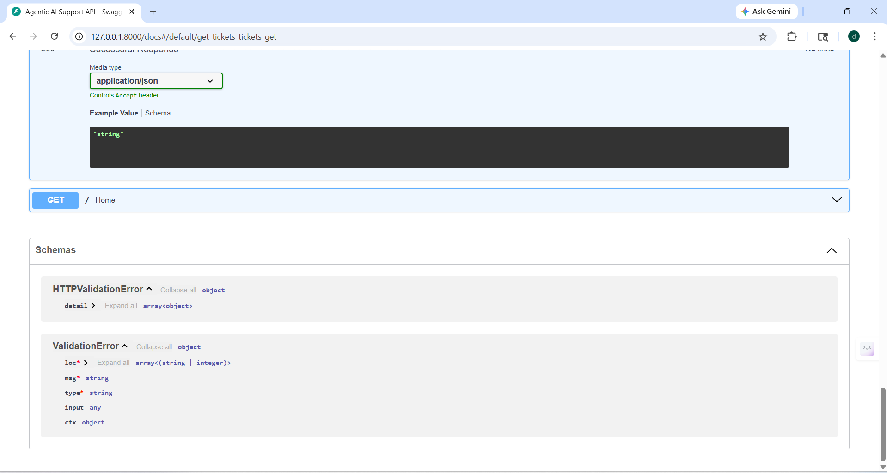

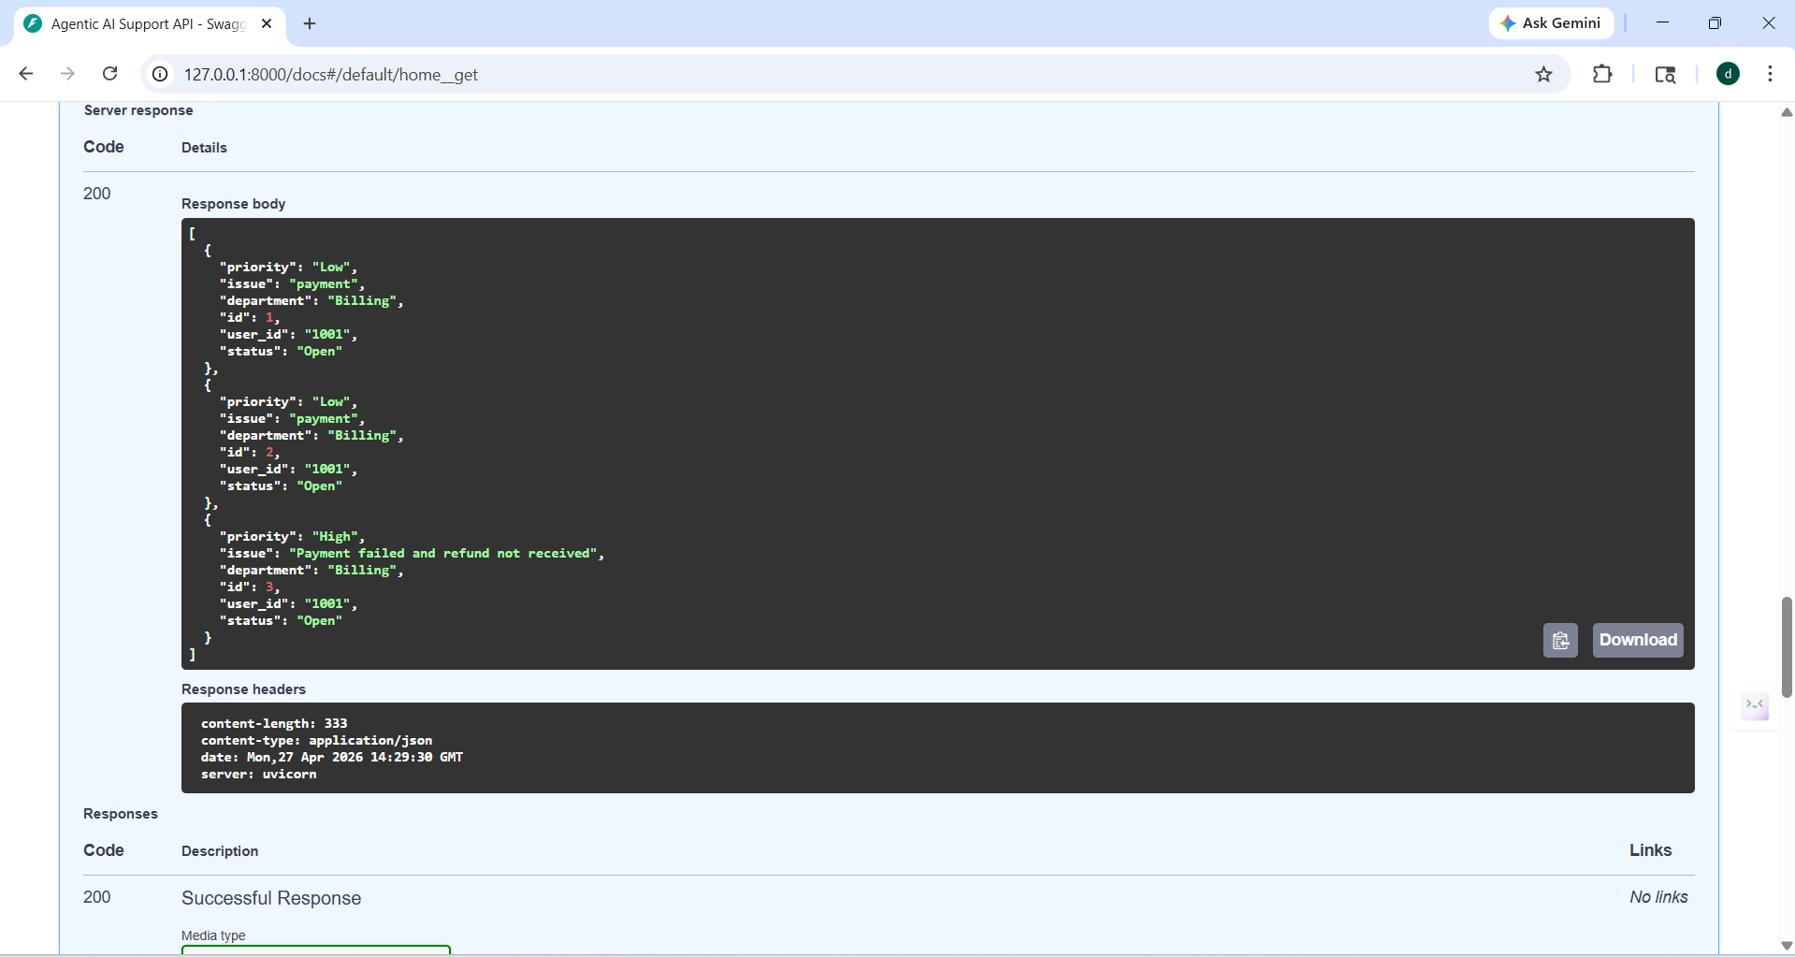

== after updating of all files, new phase tools APIs added

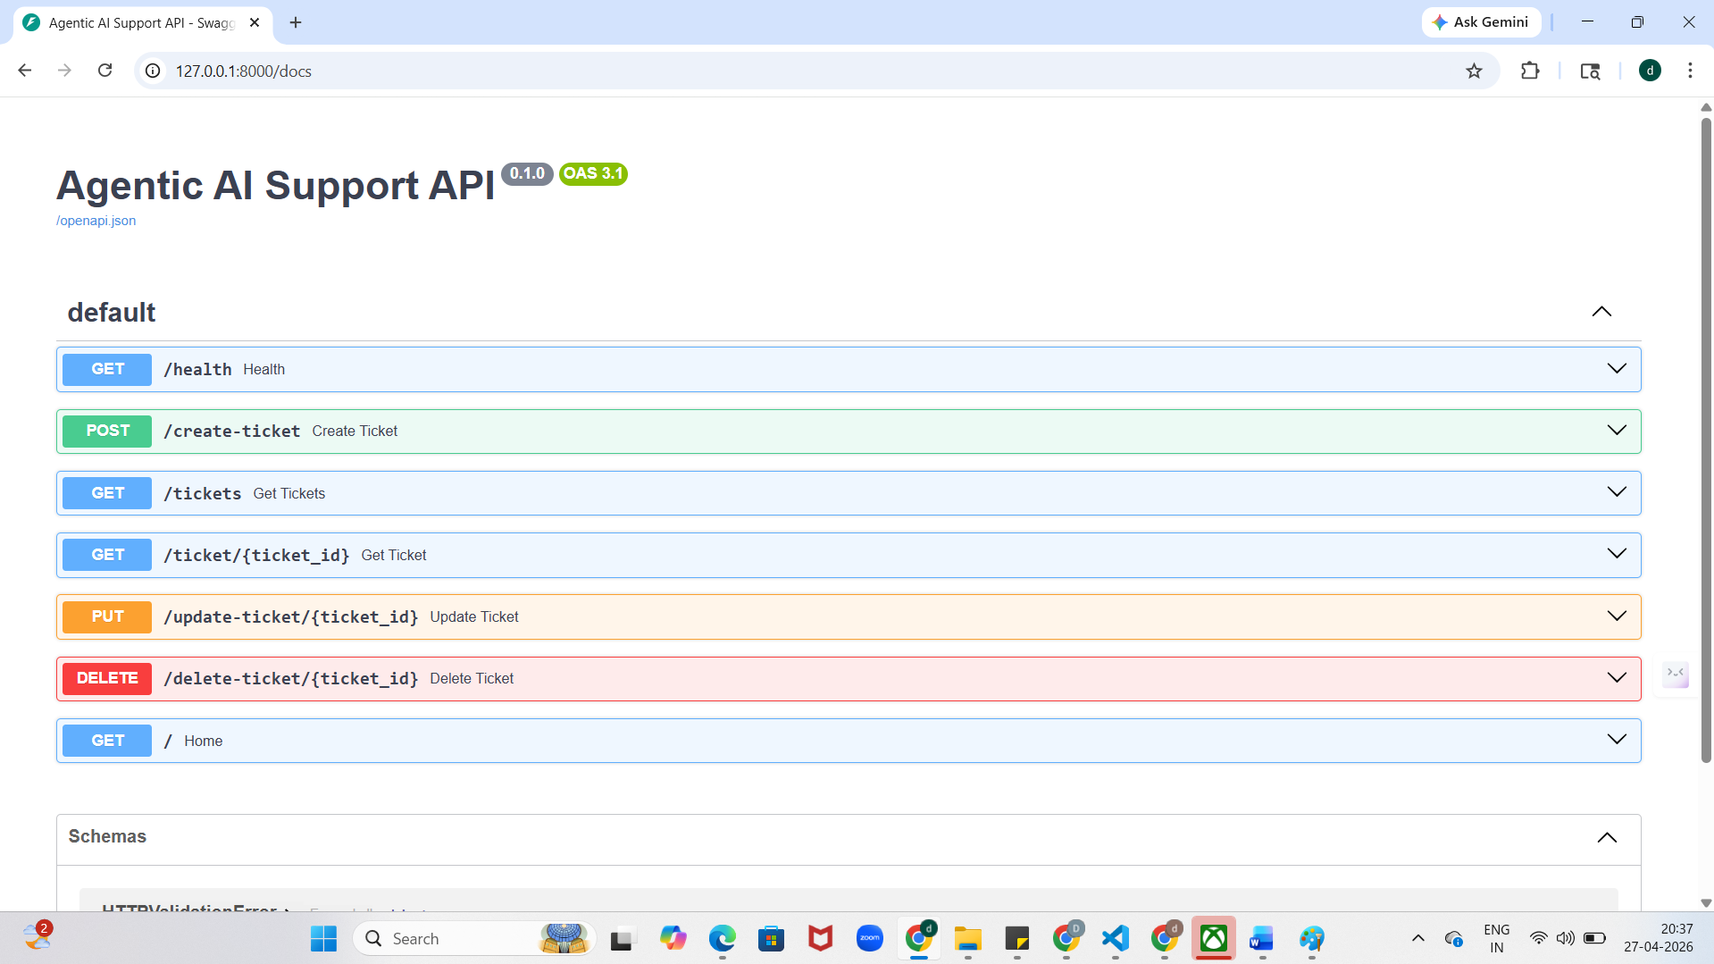

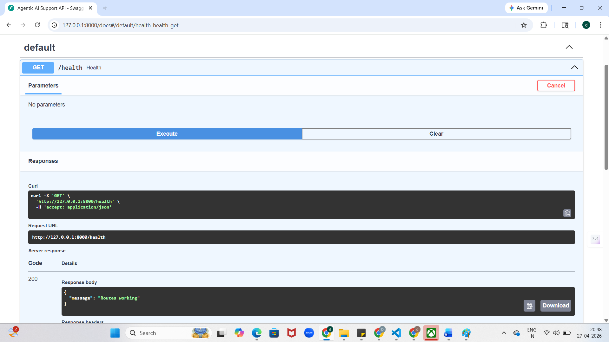

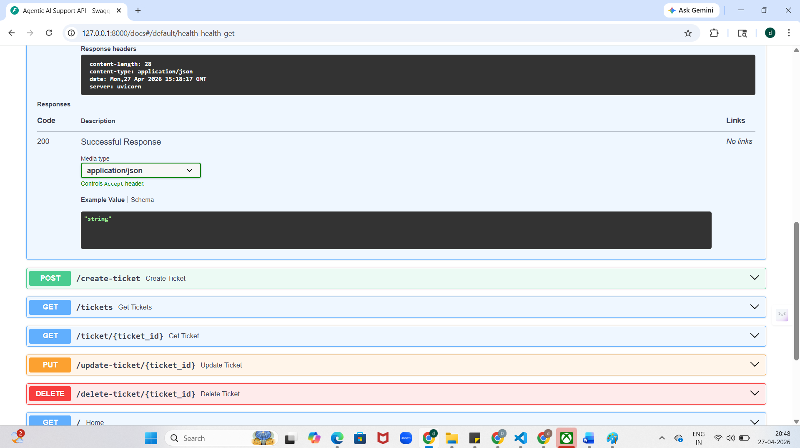

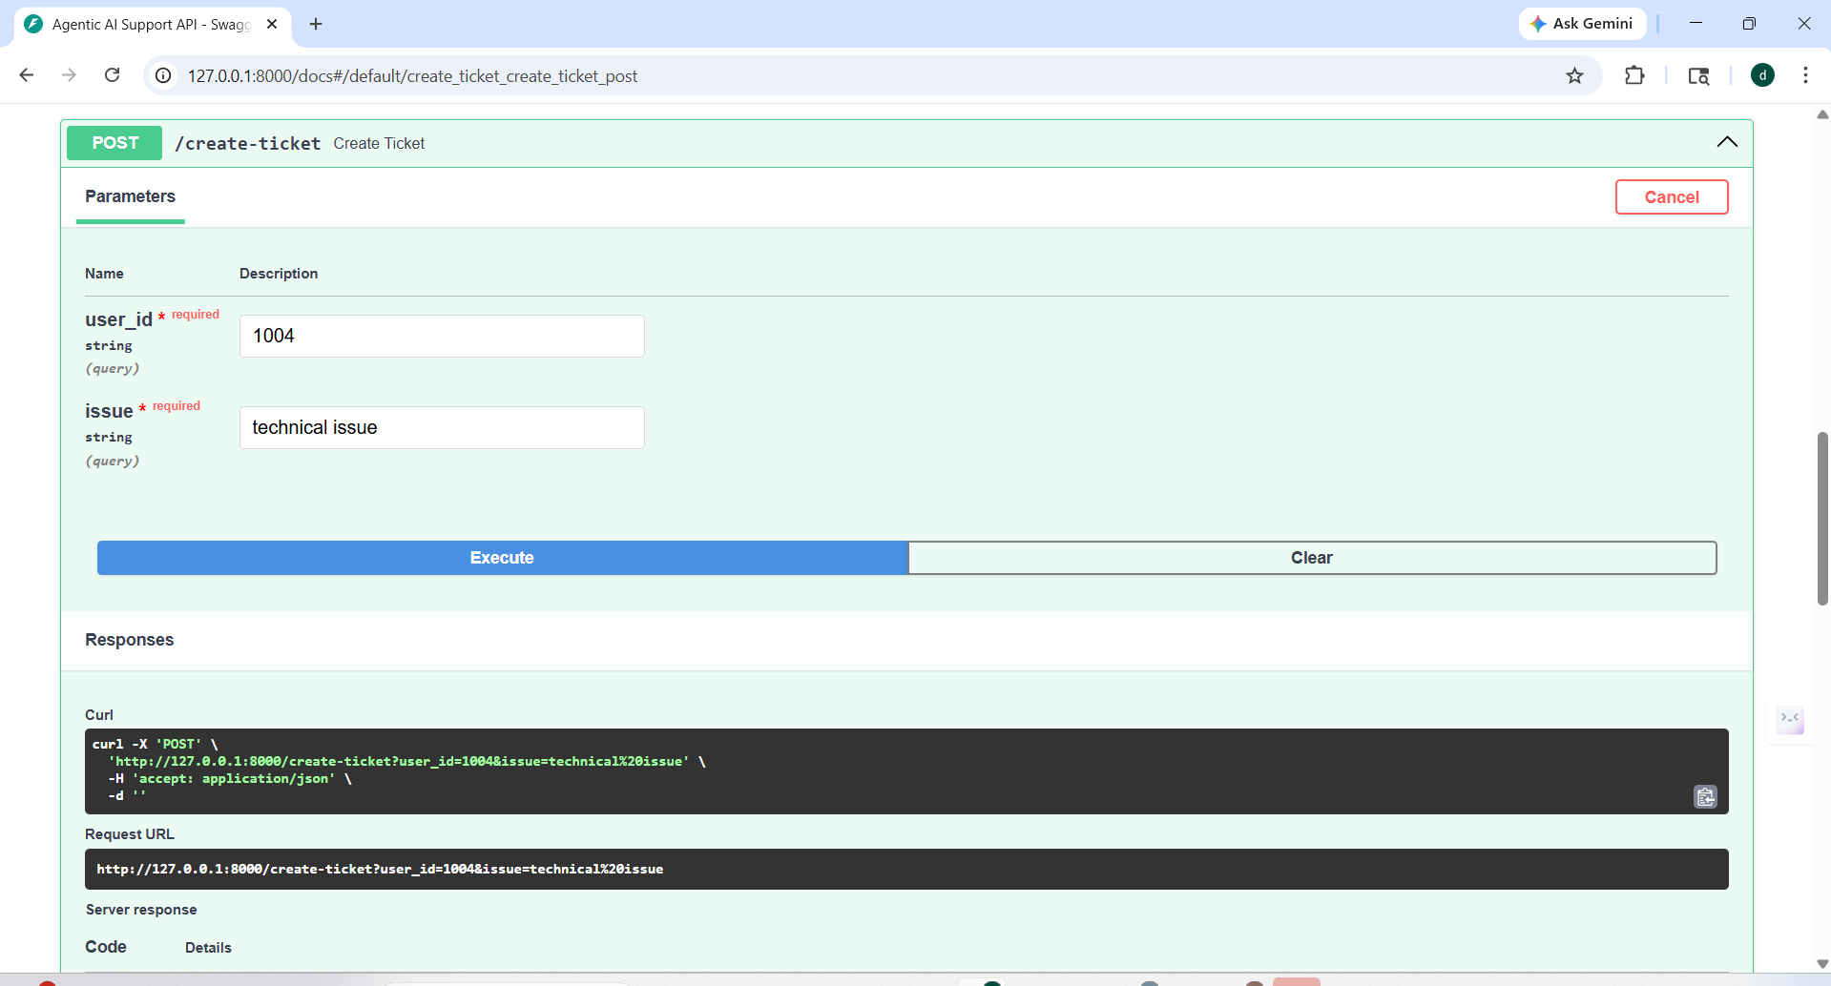

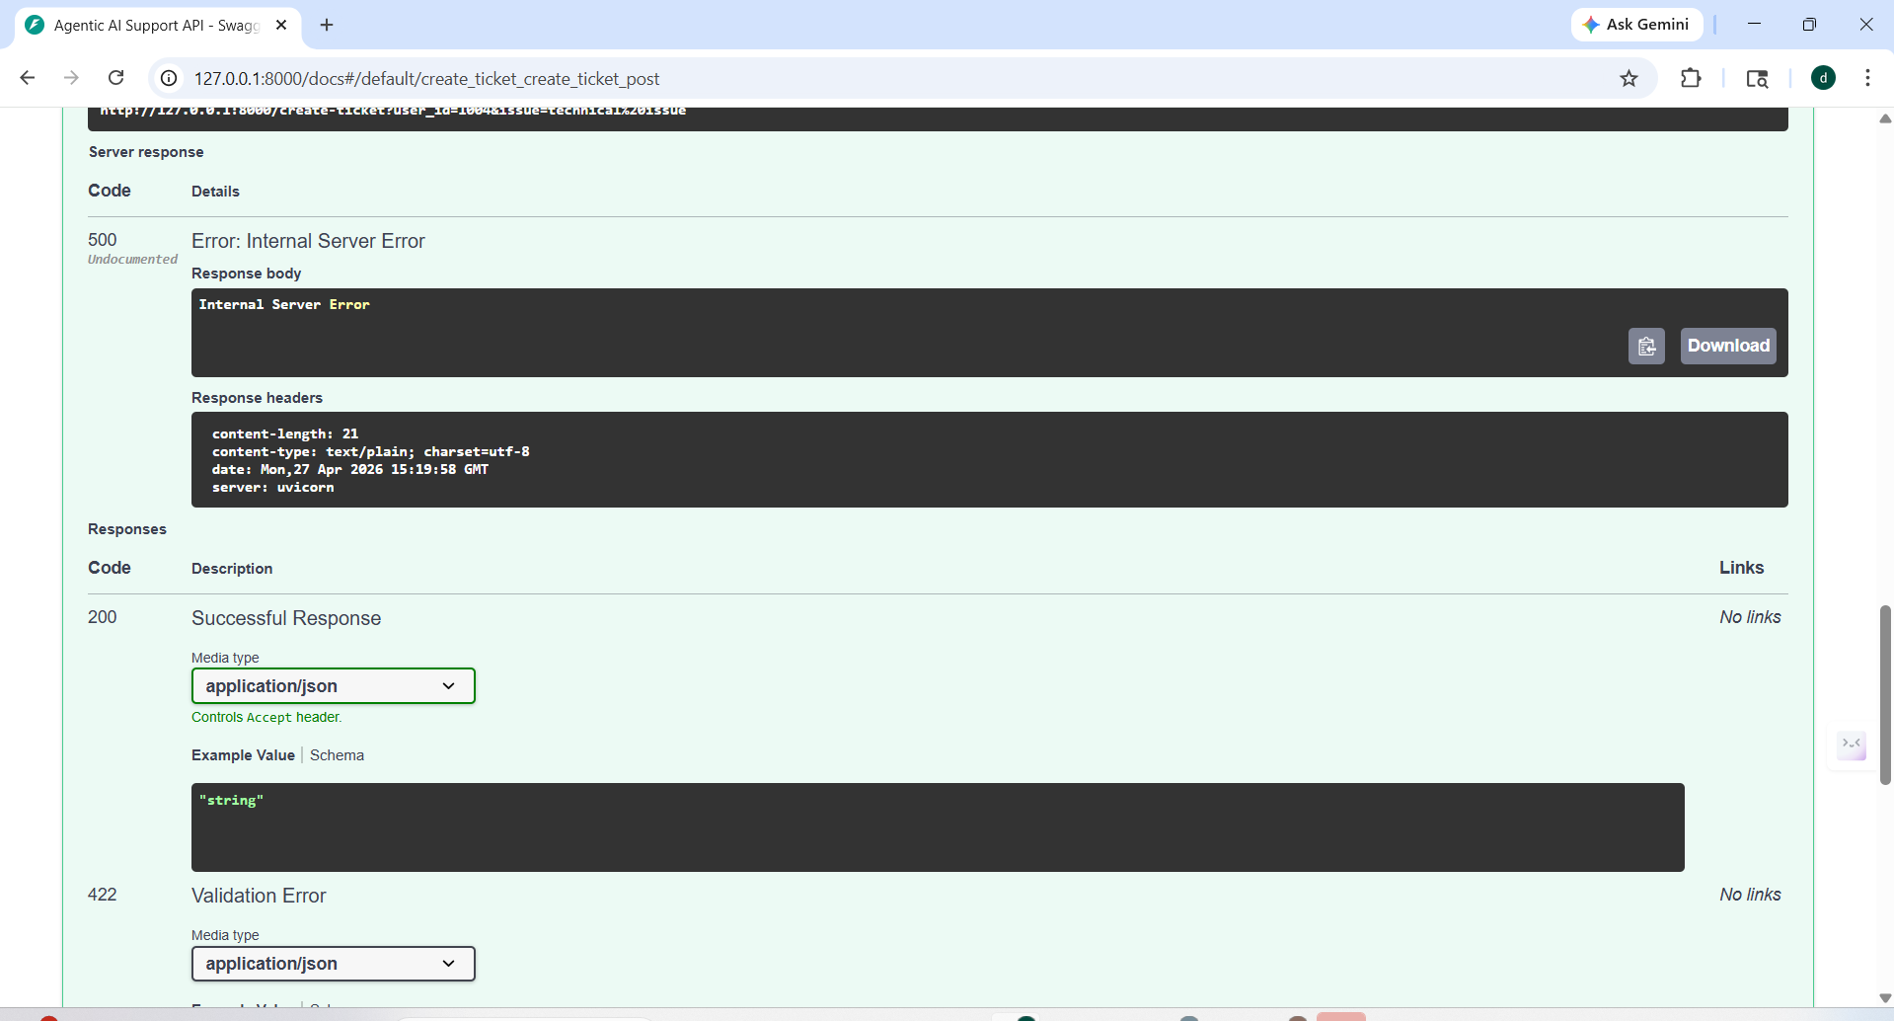

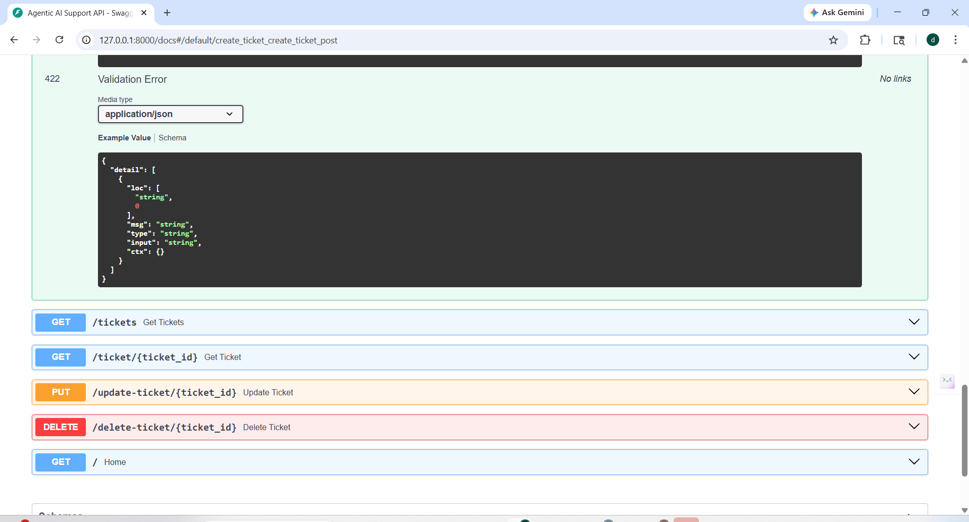

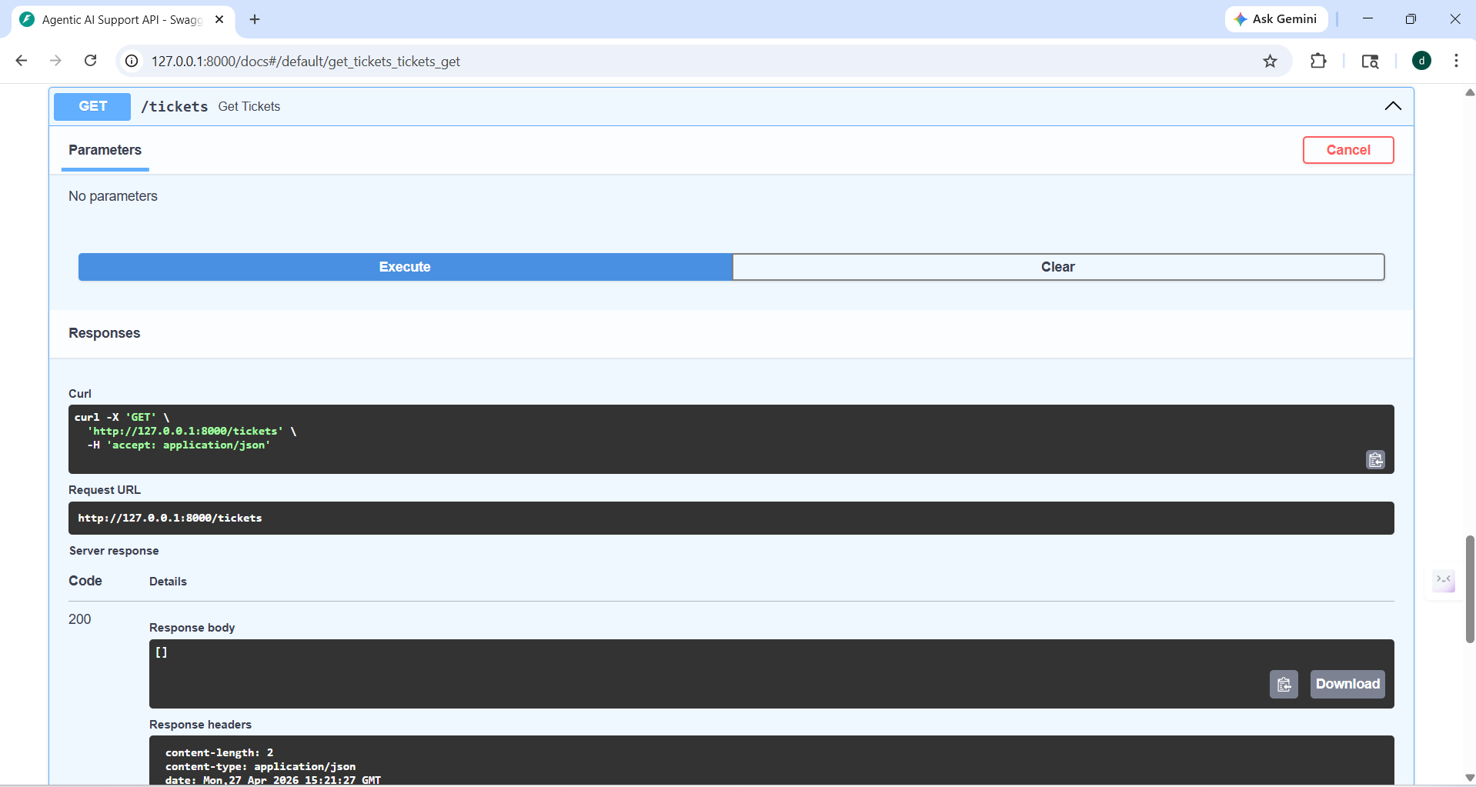

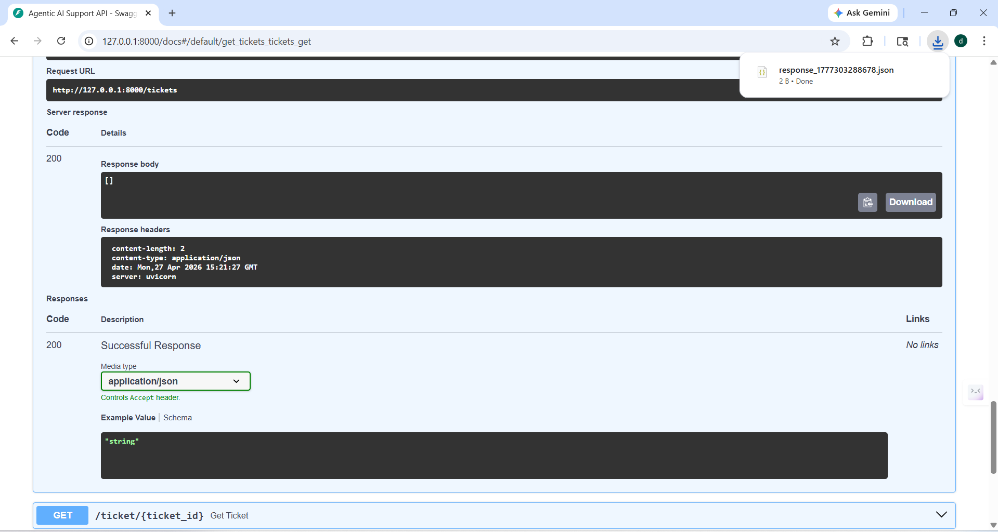

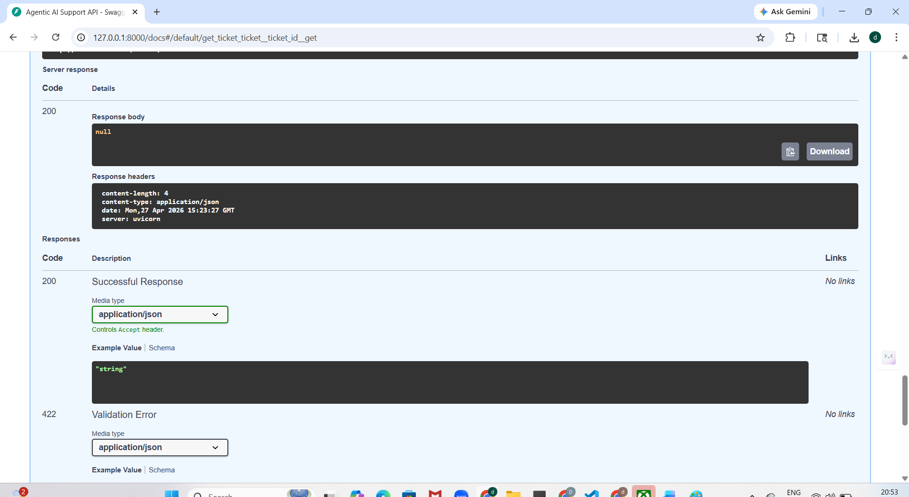

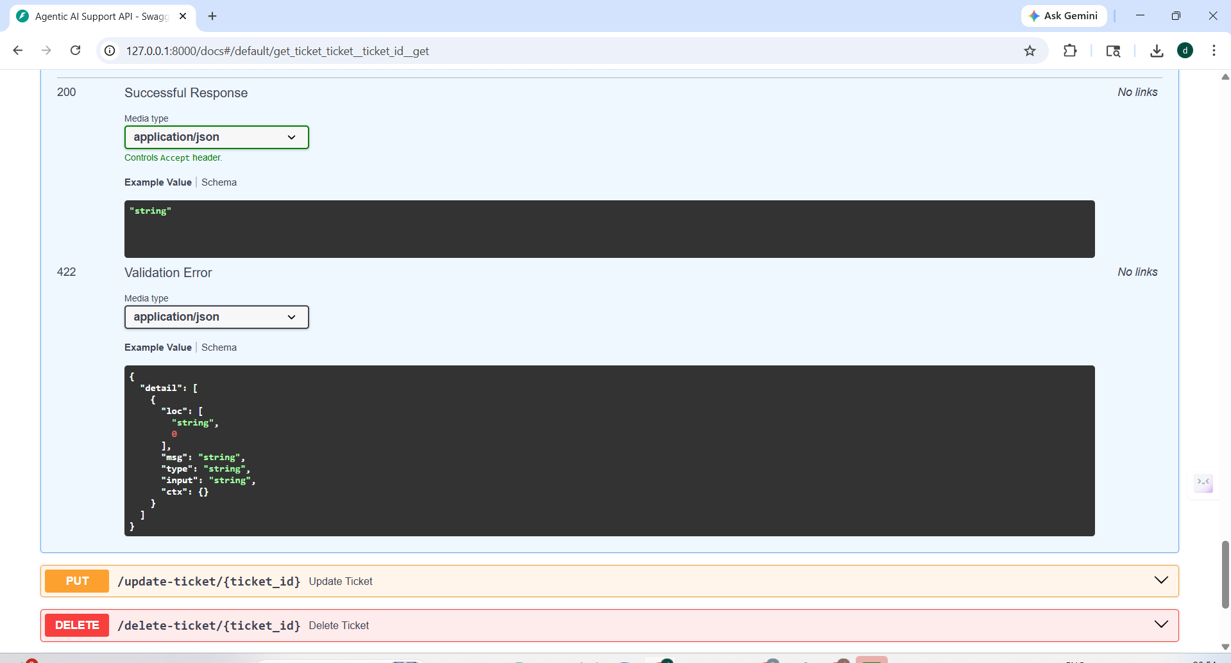

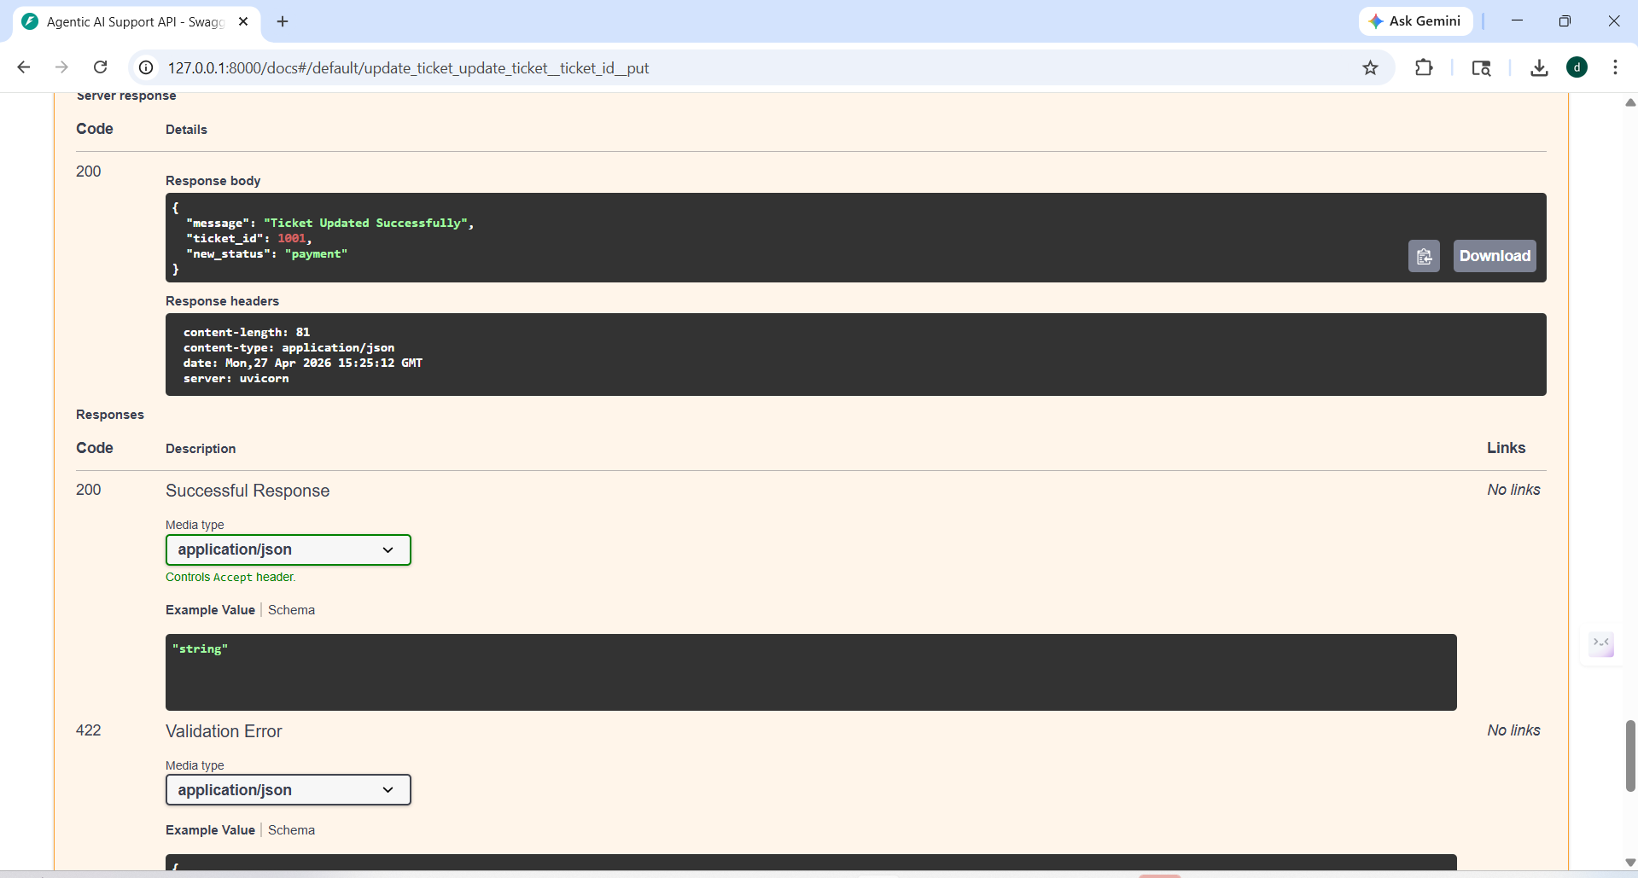

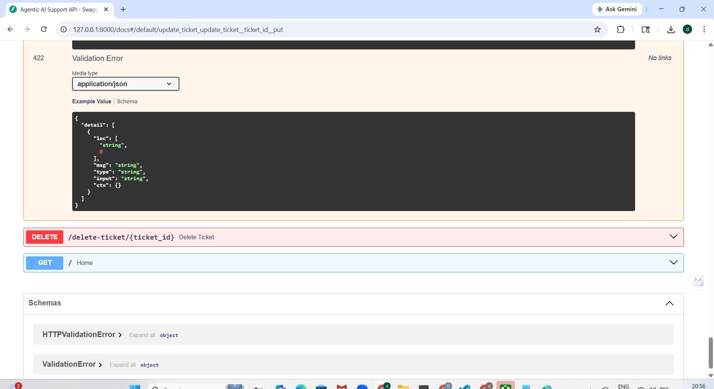

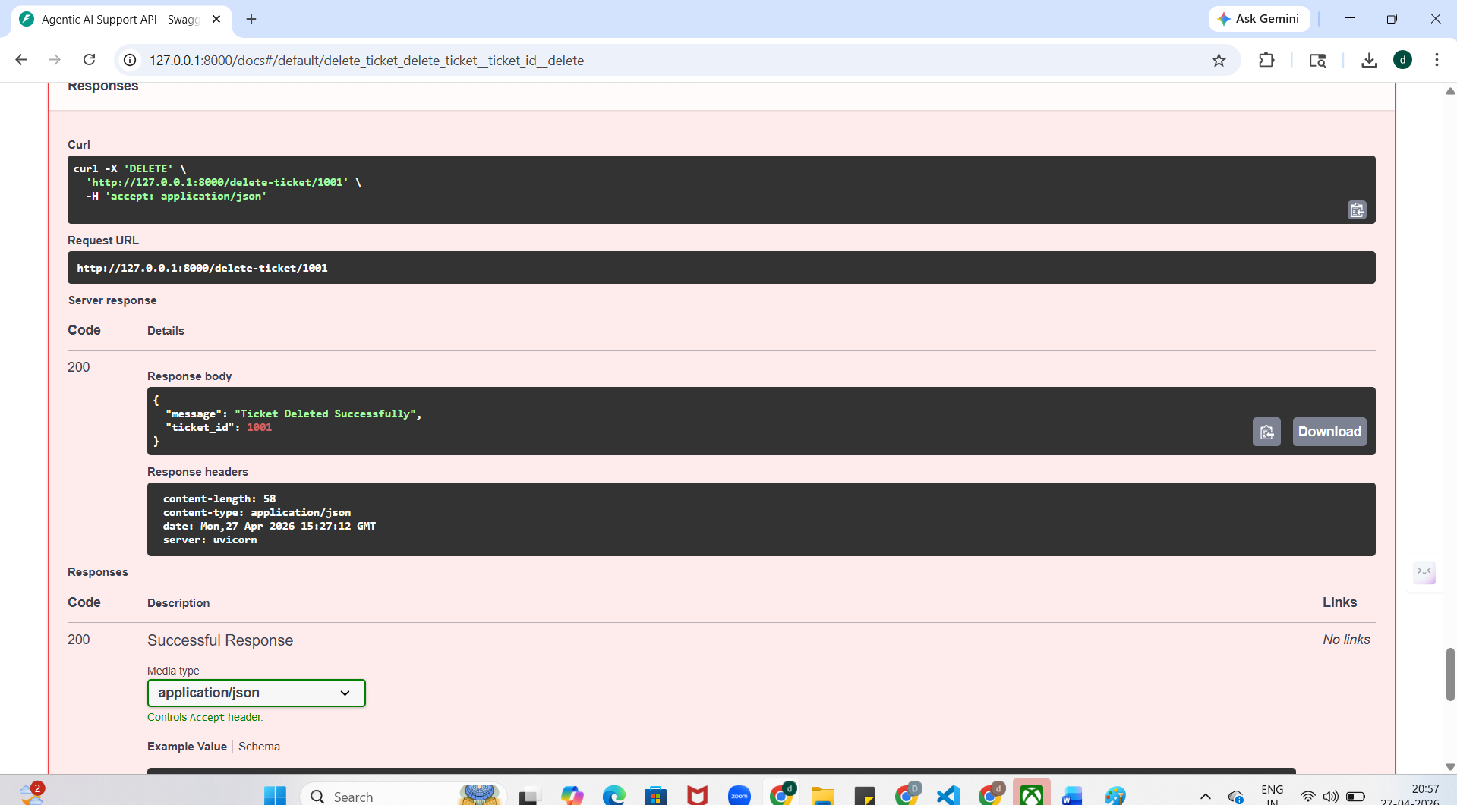

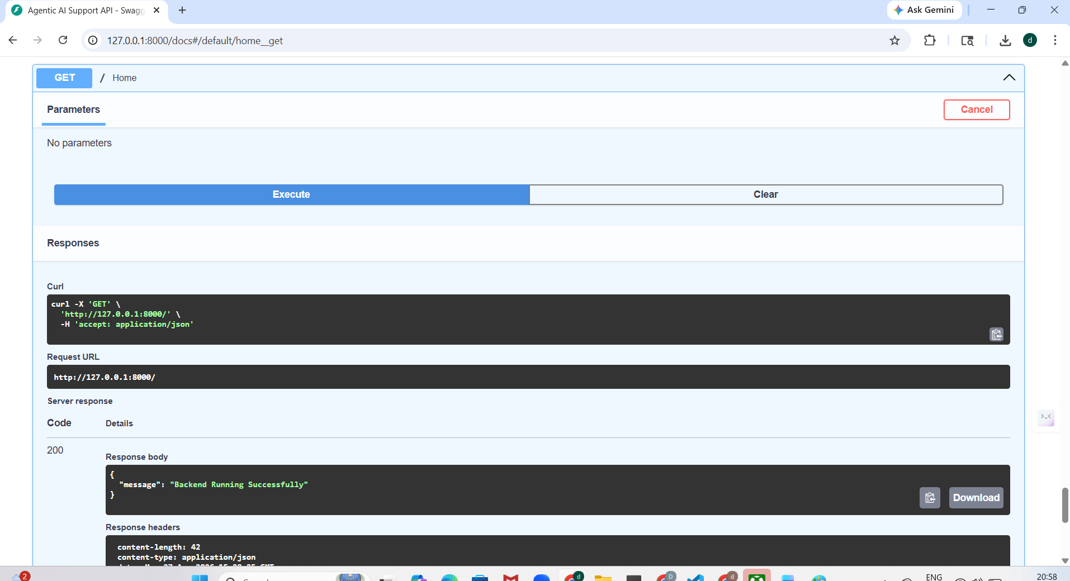

**Updated dashboard :
